A REPORT

on

STUDY OF LOW RANK APPROXIMATIONS AND

GRAPH CLUSTERING TECHNIQUES

Prepared By

* ABDUL KHIMANI 2017B4A70696P
* DHRUV PATEL 2017B4A70583P



BIRLA INSTITUTE OF TECHNOLOGY AND SCIENCE,PILANI

PILANI CAMPUS

September 2019

A REPORT

ON

STUDY OF LOW RANK APPROXIMATIONS AND

GRAPH CLUSTERING TECHNIQUES

PREPARED BY

* ABDUL KHIMANI 2017B4A70696P
* DHRUV PATEL 2017B4A70583P

PREPARED IN FULFILLMENT

OF  
STUDY PROJECT(MATH F266)

BIRLA INSTITUTE OF TECHNOLOGY AND SCIENCE,PILANI

PILANI CAMPUS

SEPTEMBER 2019

Acknowledgements

We are highly thankful to our Head of Department Dr. Bhupendra Kumar Sharma for giving us this opportunity to pursue the course on Study Project(MATH F266).

We are indebted to Prof. Rajiv Kumar who constantly guided us , right from the start of the project. Without him, it would not be possible for us to gain much knowledge in a very short span of time.

We are also grateful to Mr. Giridhar M. Kunkur, Chief Librarian for extending us his support and providing us access to various library resources that helped us to prepare this report.

Abstract

In this article, we present a review of low rank approximations and graph clustering techniques. Our aim is to use low rank approximations for community detection in social network graphs. Graphs contain millions of vertices and billions of edges and traditional approaches to clustering run against computational constraints. Low rank approximations produce suboptimal matrices with an added advantage of lower time complexity that can be applied to larger systems. We present a brief overview of CUR decompositions, SVD and QR factorizations for low rank approximations. Graph clustering techniques such as spectral and hierarchical have also been discussed.

**TABLE OF CONTENTS**

Acknowledgements……………………………………………………………………………...i

Abstract……………………………………………………………………………….…………..ii

1. Introduction…………………………………………………………………………........6

2. Low Rank approximation algorithms….…………………………………………….....7

2.1 Singular value decomposition…………………………………...……………..7

2.1.1 Uniqueness…….………………………………………………………….7

2.1.2 Applications……………………………………………………………….7

2.2 QR decomposition……….…..….………………………….…………………..8

2.2.1 Uniqueness………………………………………………………………..8

2.2.2 Applications……………………………………………………………….8

2.3 CUR decomposition….………………………...……………………...……….9

2.3.1 Uniqueness………………………………………………………………..9

3. Clustering algorithms……………………………………………….………………….10

3.1. Spectral graph clustering……………………………..………………………12

3.1.1 Background and Literature survey…………………………………….12

3.1.2 Similarity graphs…………………………………………..…………….12

3.1.3 Graph Notation…………………………………………………………..13

3.1.4 Different Similarity Graphs……………………………………………..14

3.1.5 Graph Laplacians and their basic properties………………………...15

3.1.6 Spectral Clustering Algorithms………………………………………...17

3.2. Hierarchical clustering……………………………………...…………………..19

3.2.1 Introduction to Hierarchical Clustering……………………………...19

3.2.2 Similarity measures…………………………………………………...20

3.2.3 Types of Hierarchical clustering……………………………………..21

3.2.4 Hierarchical Clustering Algorithms…………………………………….22

3.2.5 Choosing the number of clusters……………………………………...23

4. Girvan-Newman Algorithm……………..………………………………………………..26

4.1 Edge Betweenness………………………………………………………………..26

4.2 Breadth First Search……………………………………………………………...27

4.3 Girvan Newman - The Essence of Algorithm……………………………….…29

4.4 Modularity and number of clusters……………………………………………...29

4.5 Illustration with an example………………………………………………………31

5. Quality Measures for Clustering…………………………………………………………..35

5.1 Graph Notations…………………………………………………………………35

5.1.1 Modularity……………………………………………………………...36

5.1.2 Silhouette Index……………………………………………………….37

5.1.3 Coverage……………………………………………………………….37

5.1.4 Performance…………………………………………………………...37

6. Clustering Using Network Topology……………………………………………………..39

6.1 Algorithms and Complexity……………………………………………………..40

6.2 Evaluation Measures…………………………………………………………….41

6.3 Application of this algorithm…………………………………………………....41

7. Bibliography……………………………………………………………………………..…45

8. Appendix…………………………………………………………………………………...47

**1. Introduction**

With the boom in data in not more than in the past 10-15 years , the need for sorting out of the data has become ubiquitous. In almost every field , be it Bioscience , Geoscience , social networks or telecom industry , there is so much data to segregate that it’s now impossible to be done by the men themselves. That is where the need of efficient techniques arises which can group data with similar characteristics together so that making interpretations out of it becomes easy. There are already many efficient techniques found which are applied successfully to make meaning out of the data. This is what our study project is based on.

The purpose of our study project is to explore different well known algorithms on low rank approximations and several graph clustering algorithms which already exists in the literature. After completing a thorough study on these topics we have planned to implement one of the efficient techniques to cluster a social network dataset.

Due to paucity of time , we could not cover more than three algorithms in low rank approximations and not more than three in graph clustering algorithms. However there is so much depth in the field that if given time we could possibly explore many other techniques which might be useful implementing them in many cases

The report is divided into two major parts. The first part covers covers the details about low rank approximations which reduces the matrix of higher dimensions into lower dimensions without sacrificing significant quality. This part consists of three subparts on SVD decomposition, QR factorization and CUR decomposition. Each of these subpart explains well about each of the decomposition technique along with its present day applications.The second part covers details about different graph clustering techniques. We first look into computational complexity of clustering algorithms. Further sections explore spectral clustering and hierarchical clustering in detail.

**2. Low Rank Approximations**

Traditional methods in information retrieval and machine learning deal with data in vectorized representation. A collection of data is then stored in a single matrix A ∈ Rn×m , where each column of A corresponds to a vector in the n dimensional space. A major benefit of this vector space model is that the algebraic structure of the vector space can be exploited. However, crucial information intrinsic in the data should not be removed under this simplification. A widely used method for this purpose is to approximate the single data matrix, A, with a matrix of lower rank. Mathematically, the optimal rank-k approximation of a matrix A, under the Frobenius norm can be formulated as follows: Find a matrix B ∈ Rn×m with rank(B) = k., such that ||A−B|| is minimum. The matrix B can be readily obtained by computing the Singular Value Decomposition (SVD) of A, as stated by Golub and Van Loan, 1996. For any approximation M of A, we call ||A − M||F the reconstruction error of the approximation. Computing a low-rank approximation using the SVD is appealing from a theoretical point of view, since it provides the closest matrix with a given rank. For many applications where the data matrix is large, calculating the SVD can be impractical since it requires a large number of operations and it has large memory requirements. Recent research has thus focused on algorithms that are suboptimal, in the sense that the low-rank matrices that they calculate are not the closest possible to the original matrix. The advantage of using such algorithms is that they are faster than the SVD-based algorithm and need less memory, making them much more suitable for large scale applications. Low-rank approximations have found numerous applications in various fields. Examples include Latent Semantic Indexing, Support Vector Machine training, Computer Vision, and Web Search models. In this applications, the data consist of a matrix of pairwise distance between the nodes of a complex network and approximated by a low-rank matrix for fast community detection using distance based partitioning algorithm. Calculating such a low-rank approximation can reveal the underlying structure of the data and allow for fast computations.

**2.1 Singular Value Decomposition**

Singular value decomposition (SVD) is a celebrated matrix decomposition algorithm which has a long and fascinating history of its evolution. It is by far the best matrix decomposition technique out of all other decomposition techniques in terms of frobenius norm.

In this algorithm we decompose any arbitrary matrix A into three matrices U,V and Σ such that A=UΣV and U,V are unitary matrices and Σ is a diagonal matrix , in general. In a case when A is real matrix , then U and V are real orthogonal matrices. This method is primarily based on computing eigen decomposition of AAT.

**2.1.1 Uniqueness of SVD**

There are k=min(rows,columns) singular values of a matrix A and r is the rank of A. Then there are r positive singular values and remaining values(if r<k) are 0. Thus we can say that singular values are unique however singular vectors are not. For example , if σ > 0 is a multiple singular value then the corresponding vectors of matrix V can be chosen as any orthonormal basis of the space spanned by eigenvectors associated with multiple eigenvalue λ=σ2 of AAT

**Applications**

SVD has found vast applications in control theory, signal and image processing, speech synthesis, pattern recognition, time series analysis, electrical network theory and biomedical engineering.

In signal and image processing , SVD is used to remove unwanted background noise from the sample. Thus it acts as a filter. For example , if we take a voice sample of a person speaking then speech will be absent in around 50% of the time. In time of absence of speech there may be background noises like fan, vibrating object or maybe people speaking in the background. Our aim is to enhance the ratio of speech signal to background noise signals which is done effectively by SVD.

**2.2 QR factorization**

QR factorization is a matrix decomposition technique which decomposes a matrix A into product of matrices Q and R such that A = QR where Q is an orthogonal matrix and R is an upper triangular matrix. It is next accurate technique after SVD in terms of solution but slightly faster than SVD.

There are two main techniques to find the QR factorization of any arbitrary matrix A. These methods are namely *Householder QR factorization* and *QR factorization using Givens* matrices. Both these methods have proven numerical stability. While comparing between these two methods, Householder method requires less floating point operations compared to Givens method (2n3/3 flops compared to 4n3/3 flops approximately), but Givens method has its own advantage as it is suitable for parallel computations of matrices.

**2.2.1 Uniqueness of QR factorization**

QR factorization of any matrix A is unique only if A is nonsingular. Moreover , it is also a requirement that diagonal entries of upper triangular matrix R must be positive.

**2.2.2 Applications**

QR factorization provides a relatively easy way to solve the system of equations AX = B without inverting the matrix A. Since A can be decomposed into QR and Q is an orthogonal matrix , hence the system of equations can be written as RX=QTB which could be easily solved as R is an upper triangular matrix.

QR decomposition is also very helpful in solving least squares problem which is a standard problem in regression analysis where there are more equations than unknowns.

**2.3 CUR decomposition**

CUR is another matrix decomposition technique that chooses selectively some desired number of rows and columns of any arbitrarily given matrix A and expresses them into product of three matrices namely C,U and R such that their product approximates to matrix A.

CUR method was evolved as an alternative to single value decomposition . Although CUR decomposition is less accurate than SVD however the main advantage lies in the fact that columns of matrix C are subsets of columns of matrix A and columns of matrix R are simply subsets of row vectors of matrix A hence in this case , interpretation of data becomes easy. While in the case of SVD, the column vectors of leftmost matrix represents data in rotated space.

There are several algorithms present in the literature for computing CUR decomposition. One such algorithm which we studied is LeverageScore. CUR in which selection of column vectors of matrix A depends on the leverage score which we calculate for each column vector.

For computing leverage score , we need to represent matrix A into SVD decomposition of matrices U, Σ and V such that A=U Σ VT. Alternatively we can also represent each column of A individually as

A:,j = U Σ Vj,:T = Σi,i U:,i Vj,i where A:,j represent jth column vector of A and similarly U:,i represents ith column vector of U.

We can truncate this summation to k<n as per the requirement to reduce matrix dimension. In that case the formula becomes A:,j ≅ U Σ Vj,:T = Σi,i U:,i Vj,i

Now we define leverage score of each column vector of A as score(A:,j)=Vj,i2 . Interestingly sum of scores of each column vector is equal to k. Thus we can assign a probability to each column vector equal to πj = score(A:,j)/k (normalized statistical leverage score) so that the sum of these values becomes 1.

Now we use column select algorithm on A that computes which columns should be included in C based on statistical leverage score.

**Algorithm for COLUMNSELECT**

* Compute normalized statistical leverage scores of each column vector.
* Keep the jth column of A with probability pj = min{1, cπj}, for all j ∈ {1, ... , n}, where
* c = O(k log k/ϵ2).
* Return the matrix C consisting of the selected columns of A.

Now we just apply the above algorithm to find C , U and R using the following steps:

* Run COLUMNSELECT on A with c = O(k log k/ϵ2) to choose columns of A and construct the matrix C.
* Run COLUMNSELECT on AT with r = O(k log k/ϵ2) to choose rows of A(columns of AT) and construct the matrix R.
* Define the matrix U as U = CAR+, where X+ denotes a Moore–Penrose generalized inverse of the matrix X.

**2.3.1 Applications**

CUR finds its applications in a variety of domains. It is used in customer recommender system where from a small sample survey , we are able to predict whether a particular product would be of interest to a particular customer based on his/her previous ratings. It is even useful in medical imaging where compression of data becomes necessary without sacrificing its classification quality.

**3. Graph Clusterings**

Big Data refers to the substantial growth of heterogeneous data flows due to the increased use of newer technologies. With the advent of the Web, the use of social networking apps, mobile, connected and communicating entities, information is now more abundant than ever, and it is growing every day. Some studies argue that handling and using these huge techniques and data intelligently has the potential to become a new pillar of research and economics, experimentation, and simulation. Indeed, many opportunities of Big Data appear in different areas such as health (enhancing the efficiency of some treatments), bio-medical, marketing, transportation (reducing costs), business, finance (minimizing risks), management, social media, and government services. Clustering is the solution to the Big Data Problem. Clustering is among one of the most widely used techniques for data analysis, with applications in computer science, statistics, social sciences or psychology, and biological sciences. In almost every scientific field dealing with huge amounts of empirical data, we get the tentative idea of how our data is organized with the help of similar structure in data. In this article, we would introduce the reader to various clustering algorithms. We first present the analysis of computational time complexity of clustering algorithms and then proceed to different techniques for clustering.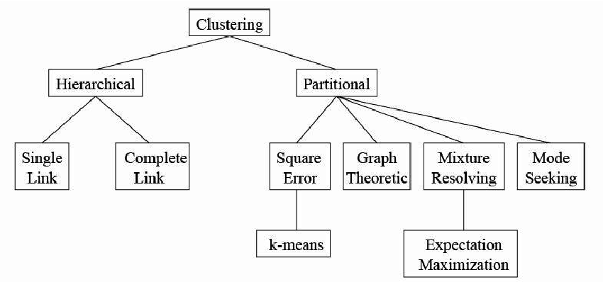

**Computational Complexity in Clustering**

The huge amount of data on real networks currently available makes the issue of efficiency of clustering algorithms crucial. An algorithm's computational complexity is the tentative estimate of the amount of resources required by an algorithm to perform a particular task. This takes into account the number of computation steps and the amount of memory that need to be allocated simultaneously to run the program. When it comes to graphs, the size is indicated by the number of vertices n and/or the number of edges m. Calculating computational complexity is a hard task. In fact, sometimes even impossible. It is, however, essential to have at least an estimate of an algorithm's worst-case complexity, which can be calculated as the number of computational resources needed for an algorithm to run in the most unfavorable case for a given size of the system. The symbol O(nm) points out that the time complexity grows as a power of edges and vertices, exponentially. We would like to have the lowest possible values for the exponents, so as to reduce the time complexity. Web graphs, with billions of vertices and billions of edges, cannot be tackled by algorithms whose running time takes more than linear time in m or n.

Algorithms with polynomial complexity form the class called P. No known polynomial-time algorithms exist for important decision or optimization problems. Finding solutions to such problems in the worst-case may demand an exhaustive search, which takes more time than any polynomial function of the system size, e.g., exponentially. Problems for which solutions can be verified in polynomial time span the class NP of non-deterministic polynomial-time problems, which includes P. A problem is NP-hard if a solution for it can be translated into a solution for any NP-problem. An NP-hard problem need not belong to the class NP. If it belongs to NP, it is called NP-complete. The class of NP-complete problems has drawn special attention in computer science, as it includes many famous problems like the Traveling Salesman, Boolean Satisfiability (SAT), Linear Programming, etc.. Just because NP problems have a solution which is verifiable in polynomial time does not mean that NP problems have polynomial complexity, i.e., that they are in P. In fact, the question of whether NP or P is the most important open problem in theoretical computer science. Many clustering algorithms related to graph clustering are NP-hard. So, it is futile to use exact algorithms, which could be applied only to very systems of smaller size. Even if algorithms have polynomial time complexity, they may still be too much for large systems. In all such cases, we tend to use approximation algorithms, i.e., methods that deliver only an approximate solution, but with lower time complexity. Approximation algorithms are very often non-deterministic, as they give different solutions for the same problem, for varied parameters and/or initial conditions of the algorithm. Such algorithms deliver a solution which differs by a constant factor from the optimal solution. In several cases, it is not possible to approximate the solution within any lower bound constant, as the goodness measure of the approximation emphatically depends on the particular problem at study. Approximation algorithms are generally used for optimization problems when we want to find the minimum or maximum value of a cost function over a large set of possible system configurations.

**3.1 Spectral Clustering**

**3.1.1 Background and Literature Survey**

Spectral clustering is a well-known graph-theoretic approach of finding natural groupings in given dataset. Owing to technological progress, digital data is accumulated at unimaginable speed in various fields, such as the internet, science, engineering, biomedicine, and real-world sensing. It is not uncommon for a dataset to contain tens of thousands of samples and/or features. Spectral clustering generally becomes infeasible for analysing these big data. Spectral clustering has emerged as one of the most widely used modern clustering algorithms. It is simple to implement and can be solved efficiently by standard linear algebra software, and also performs better than traditional clustering algorithms such as the k-means algorithm. Spectral Clustering algorithms are mostly based on the Eigen-decomposition of Laplacian matrices of either weighted or unweighted graphs. In this article, we present different spectral clustering algorithms found in literature that solve these problems.In this paper, we propose a Low-rank Approximation-based Spectral (LAS) clustering for big data analytics. Our final aim is to integrate low-rank matrix approximations, i.e., the approximations to the affinity matrix and its subspace, as well as those for the Laplacian matrix and the Laplacian subspace, so thatLAS gains great computational and spatial efficiency for processing big data.

Spectral clustering dates back to Donath and Hoffman (1973), who first gave the idea to construct graph partitions on the basis of eigenvectors of the adjacency matrix. Fiedler (1973) determined that graph bipartitions are closely connected with the second eigenvector of the graph Laplacian, and he advised to use this eigenvector for graph partitions. Then onwards, spectral clustering has been discovered, re-discovered, and improvised many times in different circles, see for example , Bolla (1991), Hagen and Kahng (1992), Pothen, Simon, and Liou (1990), Simon (1991), Barnard, Pothen and Simon (1995), Hendrickson and Leland (1995), Van Driessche and Roose (1995), Spielman and Teng (1996), Guattery and Miller (1998).

In the machine learning circles, spectral clustering became popular by the works of Shi andMalik (2000), Ng et al. (2002), Meila and Shi (2001), and Ding (2004). Also, fresh theoretical insights between spectral clustering and other algorithms have been found. A relation between spectral clustering and the weighted kernel k-means algorithm is described in Dhillon et al. (2005). Relations between spectral clustering and (kernel) principal component analysis rely on the fact that the smallest eigenvectors of graph Laplacians can also be interpreted as the largest eigenvectors of kernel matrices (Gram matrices). Two different flavors of this interpretation exist: whileBengio et al. (2004) interpret the matrix D−1/2W D−1/2 as kernel matrix, other authors (Saerens, Fouss, Yen, and Dupont, 2004) interpret the Moore-Penrose inverses of L or Lsym as kernel matrix. Both interpretations can be used to construct (different) out-of-sample extensions for spectral clustering. Several literatures on spectral clustering have been published in recent years.

Spectral clustering is successful because it does not make reasonably strong assumptions on how the clusters should be distributed. In contrast to k-means, where the clusters form convex sets, spectral clustering can solve problems like intertwined spirals beyond the scope of k-means. Moreover, spectral clustering can be efficiently implemented even for large systems, as long as the similarity graph is sparse. after choosing the similarity graph, a linear problem is to be solved and we don't have to worry about getting stuck in local optimums or restarting the algorithm many times with different initializations. However, choosing a good similarity graph is not easy, and spectral clustering may be pretty unstable under distinct choices of the parameters for the neighborhood graphs. So spectral clustering cannot be used as an ultimate tool which automatically detects the perfect clusters in any data set. But it can be used as an effectual tool which can produce good results if applied with caution.

**3.1.2 Similarity graphs**

Given a set of data points x1, x2,…., xn and some notion of similarity sij ≥ 0points between all pairs of data points xi and xj , the intuitive goal of clustering is to divide the data points into several groups such that points in the same group are similar and points in different groups are dissimilar to each other. If we do not have more information than similarities between data points, a nice way of representing the data is in the form of the similarity graph G = (V, E). Each vertex vi in this graph represents a data point xi. Two vertices are connected if the similarity sij between the corresponding data points xi and xj is positive or larger than a certain threshold, and the edge is weighted by sij. The problem of clustering can now be reformulated using the similarity graph: we want to find a partition of the graph such that the edges between different groups have very low weights (which means that points in different clusters are dissimilar from each other) and the edges within a group have high weights (which means that points within the same cluster are similar to each other).

**3.1.3 Graph notation**

Let G = (V,E) be an undirected graph with vertex set V = {v1, ..., vn}.In the following, we assumethat the graph G is weighted, i.e. each edge between two vertices vi and vj carries a non-negativeweight wij ≥ 0. The weighted adjacency matrix of the graph is the matrix W = (wij) i,j=1,...,n. Ifwij = 0 this means that the vertices vi and vj are not connected by an edge. As G is undirected we require wij = wji. The degree of a vertex vi ∈ V is defined as

*di =wij*

Note that, in fact, this sum only runs over all vertices adjacent to vi, as for all other vertices vj theweight wij is 0. The degree matrix D is defined as a diagonal matrix with the degrees *d1,...,dn* on the diagonal. Given a subset of vertices *A ⊂ V* , we denote its complement *V \ A* by *A*. We define the indicator vector *⥠A = (f1, … , fn)’* ∈Rn as the vector with entries *fi = 1* if *vi ∈ A* and *fi = 0* otherwise.

We consider two different ways of measuring the “size” of a subset A ⊂ V :

*|A | : the number of vertices in A*

*vol(A) : $\sum_{i∈A }{}$ di*

Intuitively, |A| measures the size of A by its number of vertices, while vol(A) measures the size of A by summing over the weights of all edges attached to vertices in A. A subset A ⊂ V of a graph is connected if any two vertices in A can be joined by a path such that all intermediate points also lie in A. A subset A is called a connected component if it is connected and if there are no connections between vertices in A and A. The nonempty sets A1 ,..., Ak form a partition of the graph if Ai ∩ Aj = ∅ and A1 ∪ ... ∪ Ak = V .

**3.1.4 Different similarity graphs**

There are several popular constructions to transform a given set x1 , … ,xn of data points with pairwisesimilarities sij or pairwise distances dij into a graph. When constructing similarity graphs the goal is to model the local neighborhood relationships between the data points.

The ε-neighborhood graphs: Here we connect all points whose pairwise distances are smaller than ε. As the distances between all connected points are roughly of the same scale (at most ε), weighting the edges would not incorporate more information about the data to the graph. Hence, the ε-neighborhood graph is usually considered as an unweighted graph.

k-nearest neighbor graphs: Here the goal is to connect vertex vi to vertex vj if vj is amongthe k-nearest neighbors of vi. However, this definition leads to a directed graph, as the neighborhood relationship is not symmetric. There are two ways of making this graph undirected. The first way is to simply ignore the directions of the edges, that is we connect vi and vj with an undirected edge if vi is among the k-nearest neighbors of vj or if vj is among the k-nearest neighbors of vi. The resultinggraph is what is usually called the k-nearest neighbor graph. The second choice is to connect vertices vi and vj if both vi is among the k-nearest neighbors of vj and vj is among the k-nearest neighbors of vi. The resulting graph is called the mutual k-nearest neighbor graph. In both cases, after connectingthe appropriate vertices we weight the edges by the similarity of their endpoints.

The fully connected graphs: Here we simply connect all points with positive similarity with each other, and we weight all edges by sij. As the graph should represent the local neighborhood relationships, this construction is only useful if the similarity function itself models local neighbor- hoods. An example for such a similarity function is the Gaussian similarity function exp(−||xi − xj||2 / (2σ2)), where the parameter σ controls the width of the neighborhoods. This parameter plays a similar role as the parameter ε in case of the ε-neighborhood graph.

All graphs mentioned above are regularly used in spectral clustering. To our knowledge, theoretical results on the question how the choice of the similarity graph influences the spectral clustering result do not exist.

**3.1.5 Graph Laplacians and their basic properties**

The main tools for spectral clustering are graph Laplacian matrices. There exists a whole field dedicated to the study of those matrices, called spectral graph theory (e.g., see Chung, 1997). In this section we want to define different graph Laplacians and point out their most important properties. We will carefully distinguish between different variants of graph Laplacians. Note that in the literature there is no unique convention which matrix exactly is called “graph Laplacian”. Usually, every author just calls “his” matrix the graph Laplacian. Hence, a lot of care is needed when reading literature on graph Laplacians.

In the following we always assume that G is an undirected, weighted graph with weight matrix W, where wij = wji ≥ 0. When using eigenvectors of a matrix, we will not necessarily assume that they are normalized. For example, the constant vector for some a = 0 will be considered as the same eigenvectors. Eigenvalues will always be ordered increasingly, respecting multiplicities. By “the first k eigenvectors” , we refer to the eigenvectors corresponding to the k smallest eigenvalues.

**The unnormalized graph Laplacians**

The unnormalized graph Laplacian matrix is defined as

*L = D − W*.

An overview over many of its properties can be found in Mohar (1991, 1997). The following proposition summarizes the most important facts needed for spectral clustering. We present without proofs two useful propositions.

*Proposition 1 (Properties of L) The matrix L satisfies the following properties:*

*1. For every vector f ∈ Rn*

*f’Lf = $\frac{1}{2}$ ( $\sum_{i,j = 1}^{n}{}$ wij ( fi − fj ) 2 )*

*2. L is symmetric and positive semi-definite.*

*3. The smallest eigenvalue of L is 0, the corresponding eigenvector is the constant one vector.*

*4. L has n non-negative, real-valued eigenvalues 0 = λ1 ≤ λ2 ≤ ... ≤ λn.*

Note that the unnormalized graph Laplacian does not depend on the diagonal elements of the adja- cency matrix W. Each adjacency matrix which coincides with W on all off-diagonal positions leads to the same unnormalized graph Laplacian L. In particular, self-edges in a graph do not change the corresponding graph Laplacian.

The unnormalized graph Laplacian and its eigenvalues and eigenvectors can be used to describe many properties of graphs, see Mohar (1991, 1997). One example which will be important for spectral clustering is the following:

*Proposition 2 (Number of connected components and the spectrum of L) Let G be an undi- rected graph with non-negative weights. Then the multiplicity k of the eigenvalue 0 of L equals the number of connected components A1,...,Ak in the graph. The eigenspace of eigenvalue 0 is spanned by the indicator vectors Ak of those components.*

**The normalized graph Laplacians**

There are two matrices which are called normalized graph Laplacians in the literature. Both matrices are closely related to each other and are defined as

Lsym = D−1/2LD−1/2 = I − D−1/2WD−1/2

Lrw  = D−1L = I − D−1W

We denote the first matrix by Lsym as it is a symmetric matrix, and the second one by Lrw as it is closely related to a random walk. In the following we summarize several properties of Lsym and Lrw.

P*roposition 3 (Properties of Lsym and Lrw) The normalized Laplacians satisfy the following properties:*

*1. For every f ∈ Rn*

*f’Lf =wij 2*

*2. λ is an eigenvalue of Lrw with eigenvector u if and only if λ is an eigenvalue of Lsym with eigenvector w = D1/2u.*

*3. λ is an eigenvalue of Lrw with eigenvector u if and only if λ and u solve the generalized eigenproblem Lu = λDu.*

4. 0 is an eigenvalue of Lrw with the constant one vector eigenvector. 0 is an eigenvalue of Lsym with eigenvector D1/2.

5. Lsym and Lrw are positive semi-definite and have n non-negative real-valued eigenvalues 0 =

λ1 ≤ ... ≤ λn.

As it is the case for the unnormalized graph Laplacian, the multiplicity of the eigenvalue 0 of the normalized graph Laplacian is related to the number of connected components:

*Proposition 4 (Number of connected components and spectra of Lsym and Lrw) Let G be an undirected graph with non-negative weights. Then the multiplicity k of the eigenvalue 0 of both Lrw and Lsym equals the number of connected components A1,...,Ak in the graph. For Lrw, the eigenspace of 0 is spanned by the indicator vectors spanned by the vectors D1/2⥠Ai .*

**3.1.6 Spectral Clustering Algorithms**

Now we would like to state the most common spectral clustering algorithms.

We assume that our data consists of n points x1, ... ,xn which can be arbitrary objects. We measure their pairwise similarities sij = s (xi,xj) by some similarity function which is symmetric and non-negative, and we denote the corresponding similarity matrix by S = (sij) i,j=1...n.

*Unnormalized spectral clustering*

**Input**: Similarity matrix S ∈ R $n×n$, number k of clusters to construct.

• Construct a similarity graph by one of the ways described in Section 1.2. Let W be its weighted adjacency matrix.

• Compute the unnormalized Laplacian L.

• Compute the first k eigenvectors u1,...,uk of L.

• Let U ∈ R $n×k$ be the matrix containing the vectors u1, . . . ,uk as columns.

• For i = 1,...,n, let yi ∈ Rk be the vector corresponding to the i-th row of U.

• Cluster the points ( yi )i=1,...,n in Rk with the k-means algorithm into clusters C1, … ,Ck.

**Output**: Clusters A1, … ,Ak with Ai = {j| yj ∈ Ci}.

There are two different versions of normalized spectral clustering, depending which of the normalized graph Laplacians is used.

*Normalized spectral clustering according to Shi and Malik (2000)*

**Input**: Similarity matrix S ∈ R $n×n$ with the k-means algorithm into clusters C1, . . . ,Ck.

• Construct a similarity graph by one of the ways described in Section 1.2. Let W be its weighted adjacency matrix.

• Compute the unnormalized Laplacian L.

• Compute the first k generalized eigenvectors u1,...,uk of the generalized eigenproblem Lu = λDu.

• Let U ∈ R $n×k$ be the matrix containing the vectors u1, . . . ,uk as columns.

• For i = 1,...,n, let yi ∈ Rk be the vector corresponding to the i-th row of U.

• Cluster the points (yi)i=1,...,n in k with the k-means algorithm into clusters C1, . . . ,Ck.

**Output**: Clusters A1 , . . . , Ak with Ai = { j | yj ∈ Ci }.

Note that this algorithm uses the generalized eigenvectors of L, which according to Proposition 3 correspond to the eigenvectors of the matrix Lrw. So in fact, the algorithm works with eigenvectors of the normalized Laplacian Lrw, and hence is called normalized spectral clustering. The next algorithmalso uses a normalized Laplacian, but this time the matrix Lsym instead of Lrw. As we will see, this algorithm needs to introduce an additional row normalization step which is not needed in the other algorithms.

*Normalized spectral clustering according to Ng, Jordan, and Weiss (2002)*

**Input**: Similarity matrix S ∈ R $n×n$ with the k-means algorithm into clusters C1, . . . ,Ck.

• Construct a similarity graph by one of the ways described in Section 1.2. Let W be its weighted adjacency matrix.

• Compute the normalized Laplacian Lsym.

• Compute the first k eigenvectors u1,...,uk Lsym.

• Let U ∈ R $n×k$ be the matrix containing the vectors u1, . . . ,uk as columns.

• Form the matrix T ∈ R $n×k$ from U by normalizing the rows to norm 1, that is set

tij = uij/(uik2).

• For i = 1, . . . ,n, let yi ∈ Rk be the vector corresponding to the i-th row of T.

• Cluster the points (yi)i=1, . . . ,n with the k-means algorithm into clusters C1, . . . ,Ck.

**Output**: Clusters A1 , . . . , Ak with Ai = { j | yj ∈ Ci }.

All three algorithms stated above look rather similar, apart from the fact that they use three different graph Laplacians. In all three algorithms, the main trick is to change the representation of the abstract data points xi to points yi ∈ Rk. It is due to the properties of the graph Laplacians that this change ofrepresentation is useful. We will see in the next sections that this change of representation enhances the cluster-properties in the data, so that clusters can be trivially detected in the new representation. In particular, the simple k-means clustering algorithm has no difficulties to detect the clusters in this new representation.

**3.2 Hierarchical Clustering**

**3.2.1 Introduction to Hierarchical Clustering**

In general, we have very less knowledge about the community structure of a graph. It is uncommon to know the number of clusters in which the graph is split, or other indications about the membership of the vertices. So, clustering procedures like graph partitioning methods are hardly useful, and we are forced to make some reasonable assumptions about the size and number of clusters, which are often unjustified. Or, the graph may have a hierarchical structure, i.e. may show several levels of grouping of the vertices, with small clusters within large clusters, which are in turn included in larger clusters, and so on. Social networks, for instance, often have a hierarchical structure. Pertaining to such cases, one may use hierarchical clustering algorithms, i.e. clustering techniques that display the multilevel structure of the graph. Hierarchical clustering is very prevalent in social network analysis, biology, engineering, marketing, etc.

Suppose we have 4 points as below.

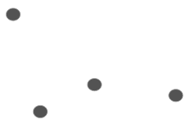

We can now consider each of these points as a separate cluster.

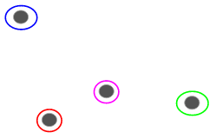

On the basis of similarity measure of these clusters, we combine the highly similar clusters collectively and reiterate this process until only a single cluster is left:

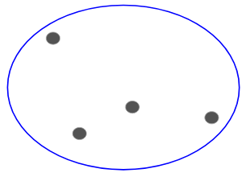

We are basically building a hierarchy of clusters. Thus , this algorithm is called hierarchical clustering.

**3.2.2 Similarity Measures**

The offset point of any hierarchical clustering method is the definition of a similarity measure between the vertices of a graph. Once a suitable measure is chosen, similarity of each pair of vertices is calculated irrespective of whether their mutual connections. At the end of this process, what is left is a new $n×n$ matrix X, the similarity matrix.

It is intuitive to assume that communities are groups of vertices that are similar to each other. One can compute the similarity between each pair of vertices with reference to some property, local or global, irrespective of edge connections. Each vertex is assigned a cluster whose vertices are most similar to it. Similarity measures are at the heart of traditional methods, like hierarchical clustering. Here we discuss some popular measures utilized in literature.

If it were possible to embed the graph vertices in an n-dimensional Euclidean space, by assigning a position to them, we can use the distance between a pair of vertices as a similarity measure (it is actually a measure of dissimilarity because similar vertices are expected to be close to each other). Given the two data points A = (a1, a2, . . . . , an) and B = (b1, b2, . . . , bn), one could use any norm Lm, like the Euclidean distance (L2-norm),

dAB = ((ak - bk)2 )

the Manhattan distance (L1-norm),

dAB = |ak - bk|

Another useful spatial measure is the cosine similarity function, defined as

AB = arccos ( a.b / ak2 . bk2 )

where a . b is the dot product of the vectors a and b.

**3.2.3 Types of Hierarchical Clustering**

Hierarchical clustering techniques try to form groups of vertices with high similarity, and can be divided into two categories.

**Agglomerative Hierarchical Clustering**

Agglomerative algorithms, in which clusters are iteratively merged if their similarity is sufficiently high.We assign each point to an individual cluster in this technique. Suppose there are 4 data points. We will assign each of these points to a cluster and hence will have 4 clusters in the beginning:



Then, at each iteration, we merge the closest pair of clusters and repeat this step until only a single cluster is left:

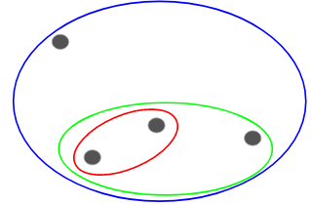

We are merging (or adding) the clusters at each step. Hence, this type of clustering is also known as **additive hierarchical clustering.**

### Divisive Hierarchical Clustering

Divisive hierarchical clustering works in the opposite way. Instead of starting with n clusters (in case of n observations), we start with a single cluster and assign all the points to that cluster. So, it doesn’t matter if we have 10 or 1000 data points. All these points will belong to the same cluster at the beginning:



Now, at each iteration, we split the farthest point in the cluster and repeat this process until each cluster only contains a single point:



We are splitting (or dividing) the clusters at each step, hence the name divisive hierarchical clustering.

The two classes refer to opposite processes: agglomerative algorithms are bottom-up, as one starts from the vertices as separate clusters (singletons) and ends up with the graph as a unique cluster; divisive algorithms are top-down as they follow the opposite direction. Divisive techniques have been rarely used in the past so we shall concentrate here on agglomerative algorithms.

**3.2.4 Hierarchical Clustering algorithm**

**Algorithmic steps for Agglomerative Hierarchical clustering**

Let X = {x1, x2, x3, ..., xn} be the set of data points.

1) Begin with the disjoint clustering having level L(0) = 0 and sequence number m = 0.

2) Find the least distance pair of clusters in the current clustering, say pair (r), (s), according to d[(r),(s)] = min d[(i),(j)] where the minimum is over all pairs of clusters in the current clustering.

3)Increment the sequence number: m = m + 1.Merge clusters (r) and (s) into a single cluster to form the next clustering m. Set the level of this clustering to L(m) = d[(r),(s)].

4) Update the distance matrix, D, by deleting the rows and columns corresponding to clusters (r) and (s) and adding a row and column corresponding to the newly formed cluster. The distance between the new cluster, denoted (r,s) and old cluster(k) is defined in this way: d[(k), (r,s)] = min (d[(k),(r)], d[(k),(s)]).

5)If all the data points are in one cluster then stop, else repeat from step 2).

Divisive Hierarchical clustering - It is just the reverse of Agglomerative Hierarchical approach.

**3.2.5 Choosing the number of Clusters**

To get the number of clusters for hierarchical clustering, we make use of a concept called a Dendrogram. A dendrogram is a tree-like diagram that records the sequence of merges or splits. We can clearly visualize the steps of hierarchical clustering. More the distance of the vertical lines in the dendrogram, more the distance between those clusters. Now, we can set a threshold distance and draw a horizontal line. Generally, we try to set the threshold in such a way that it cuts the tallest vertical line.

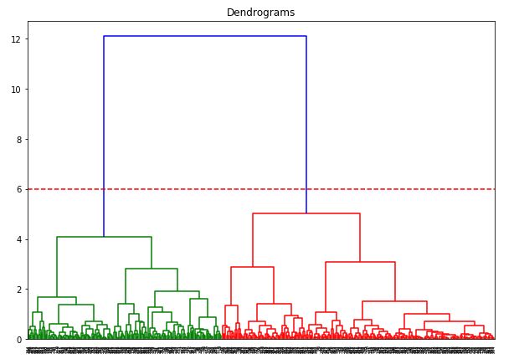

Sometimes, stopping conditions are imposed to select a partition or a group of partitions that satisfy a special criterion, like a given number of clusters or the optimization of a quality function (e.g. modularity). Hierarchical clustering has the advantage that it does not require a preliminary knowledge on the number and size of the clusters. However, it does not provide a way to discriminate between the many partitions obtained by the procedure, and to choose that or those that better represent the community structure of the graph. The results of the method depend on the specific similarity measure adopted. The procedure also yields a hierarchical structure by construction, which is rather artificial in most cases, since the graph at hand may not have a hierarchical structure at all. Moreover, vertices of a community may not be correctly classified, and in many cases some vertices are missed even if they have a central role in their clusters.

Another problem is that vertices with just one neighbor are often classified as separated clusters, which in most cases does not make sense. Finally, a major weakness of agglomerative hierarchical clustering is that it does not scale well. If points are embedded in space, so that one can use the distance as dissimilarity measure, the computational complexity is O(n2) for single linkage, O(n2log n) for the complete and average linkage schemes. For graph clustering, where distance is not trivially defined, the complexity can become much heavier if the calculation of the chosen similarity measure is costly.

.

4. **Girvan-Newman Algorithm**

For any community detection algorithm, what we want is that the algorithm should automatically detect the number of divisions among the vertices without requiring the examiner to specify the number of communities a graph should split into, or placing size restrictions and should be more general meaning that it is able to divide the community structure into more than two clusters, like most other algorithms do. Girvan and Newman propounded an algorithm that aims to achieve these goals and which has three conclusive features thus:

(1) It is a divisive clustering; edges are successively removed from a network, in contrast to the agglomerative hierarchical clustering method.

(2) The edges that should be removed are pointed out with the help of edge betweenness scores as we will describe in detail below.

(3) The betweenness scores are recomputed following the removal of each edge.

Before we delve into the algorithm, there are a few basic terminologies and algorithms that we need to acquaint ourselves with.

**4.1 Edge Betweenness**

With the advent of standard clustering methods, several specialized clustering techniques have been developed to find communities in social networks. Here, for Girvan Newman algorithm, we look at one of the simplest yet effective measures for graph clustering: Edge Betweenness.

*Definition:*

The betweenness of an **edge (v1, v2)** is the number of pairs of nodes u and w such that the edge (v1, v2) lies on the shortest path between u and w.

Precisely, given that there can be a number shortest paths between u and w, **edge (v1, v2) is credited with the fraction of those shortest paths that include the edge (v1, v2)**. A higher score of betweenness implies that the edge is a highway between two different groups and must be eliminated. It means that the edge (v1, v2) runs between two different communities; that is, v1 and v2 do not belong to the same community.

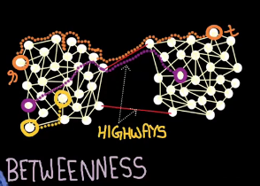

**4.2 Breadth First Search**

Breadth-first search (BFS) is a method for traversing all the nodes of a tree or graph. In BFS, you first explore the nodes that are one step away, then all the nodes that are two steps away, etc. A popular analogy presented in literature is: BFS is like throwing a stone in the center of a pond. The nodes we explore "ripple out" from the start point.

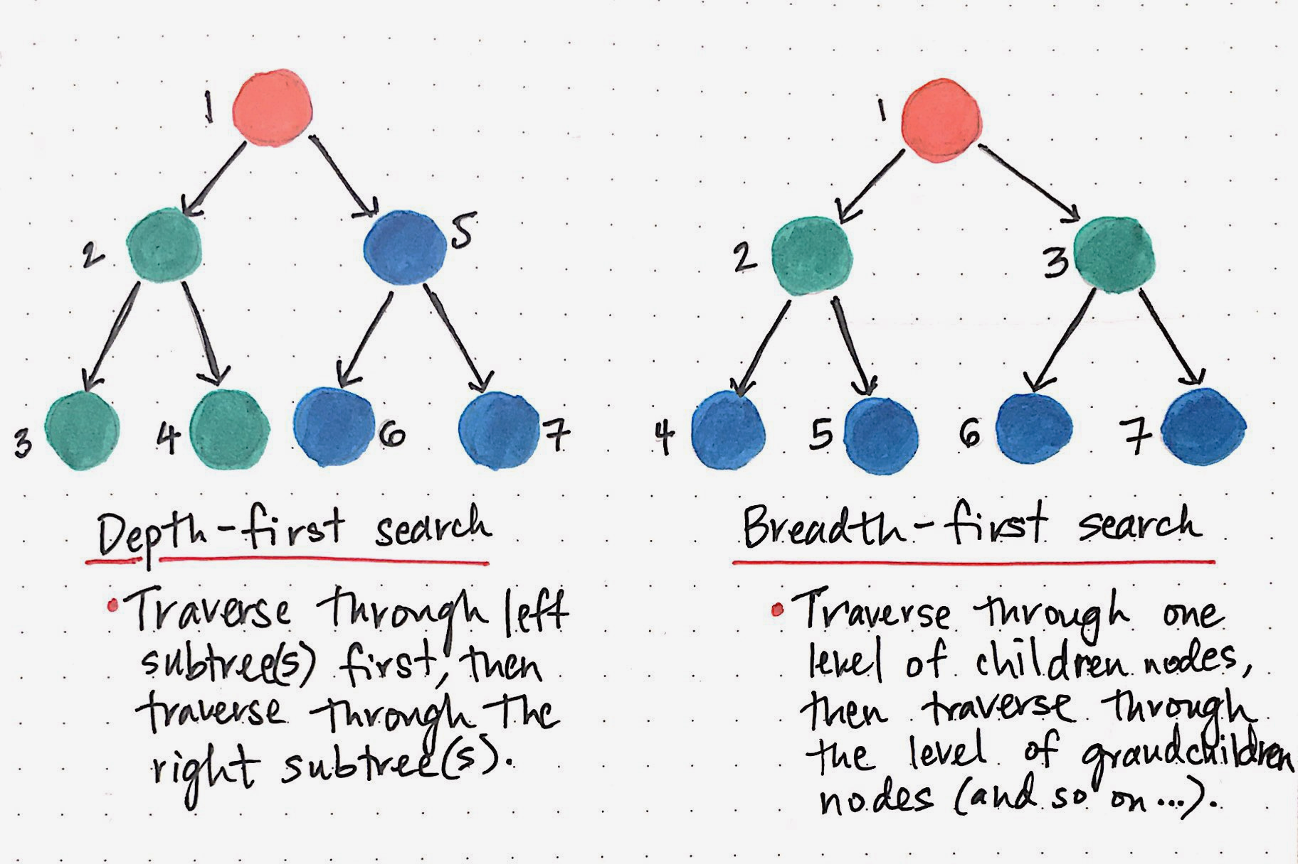

Here's how a BFS would traverse the tree

1. Start with the root:

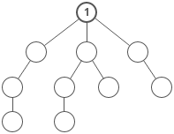

2. Visit all the immediate children (all the nodes that are one step away from starting node):

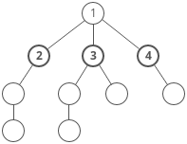

3. Visit the grandchildren:

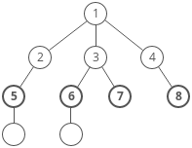 ⇒ 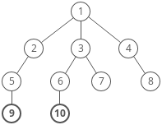

Until we reach the end.

Breadth-first search is often compared with **depth-first search**.

*Advantages*:

BFS finds the **shortest path** between the starting point and any other reachable node. Depth-first search will not necessarily find the shortest path.

*Disadvantages:*

A BFS on a binary tree requires more memory than DFS.

**4.3 Girvan Newman - The Essence of Algorithm**

The essence and motivation of the algorithm is something to ponder about. In a network such as that depicted below, the certain special edges that lie between clusters can be considered as bottlenecks between the clusters — traffic that is to pass between communities has to cross these edges in order to carry out the deed. Thus, if we consider the traffic or flow model, we can find out these edges as the one having highest flow or traffic. Removal of these edges splits our graph structure into separate clusters that appear quite natural. In order to measure traffic or flow, Girvan and Newman consider a terminology “edge betweenness”, as discussed above. We have already specified what betweenness means and now we look into how it can be used to form clusters! According to Girvan- Newan, Edge-betweenness can be calculated for all edges in time that goes as O(mn) on a graph with m edges and n vertices as stated in their paper. The algorithm then involves calculating edge-betweenness for all edges and removing the one with largest betweenness. We repeat this step until no edges remain. For a tie, we remove one randomly, or simultaneously remove all of them. The entire progress of the algorithm from start to finish can be represented as dendrogram. The algorithm can be thought of as progressing from the root of the dendrogram to the leaves, rather than the other way round, the branches of the tree representing the order of splitting of the network as edges are removed. The algorithm is more useful for general network analysis as it can split the network into more than two communities as opposed to other bisection methods. Given its advantages, the few disadvantages couldn’t be overlooked and methods to rectify them have been provided further.

**4.4 Modularity and number of clusters**

The first disadvantage being that Girvan Newman algorithm does not give us any number that the graph must be split into. To address this problem, Newman and Girvan proposed that the clusters that the algorithm gives us must be evaluated using a measure called modularity.

For a division with g groups, define a g × g matrix e whose each component eij is a fraction of edges in the original network/graph that connect vertices in group i to those in group j. Then the modularity is defined to be

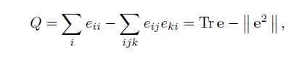

where || x || indicates the sum of all elements of x.

Another way of representing Q can be :

Q = (number of edges within groups) - (expected number of edges within groups)

*Actual number of edges between i and j is*

Aij = 1 if there is an edge (i, j), else 0

*Expected number of edges between i and j is*

Expected number = kikj/2m

m = number of edges and ki = degree of node i.

Then:

Q = $\frac{1}{4m}\{(\sum_{i,j}{}$ Aij - (ci , cj)}

where,

m = number of edges

Aij = 1 if (i,j) is edge, else 0

k i = Degree of node i

Ci = group id of node i

$δ$ (a, b) = 1 if a=b, else 0

Quantitatively, Q is the fraction of all edges that lie within clusters minus the expected value of the same quantity in a graph where the vertices have the same degrees and edges are placed randomly irrespective of the communities. Q = 0 symbolizes that the community structure is no stronger than would be expected by random chance and values other than zero represent deviations from randomness. Local maximas in the modularity during the progress of algorithm indicate some good divisions of the network. The application and definition of modularity is not dependent on a particular community structure algorithm used, and it can therefore also be applied to any other algorithm.

The other disadvantage of the algorithm of Girvan Newman is that it is slow. There are m edges to be removed and each iteration of the algorithm takes O(mn) time, the running time of the algorithm is O(m2n), or O(n3) on a sparse graph.

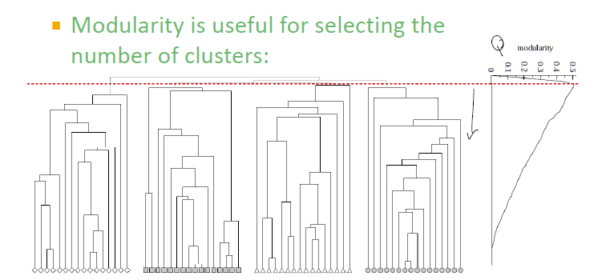

**4.5 Illustration with an example:**

The first step involves performing a breadth-first search(BFS) on the graph, starting at the node X. The level of each vertex in the BFS representation is the shortest path length from X to that particular node. Thus, the edges that are between the vertices on the same level are not a part of a shortest path from X. Consider the graph below. We will apply GN algorithm on this graph.

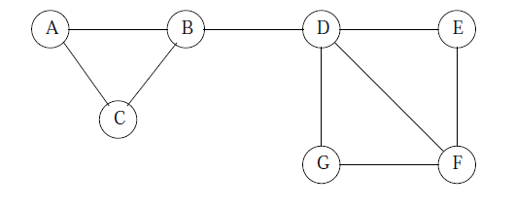.....(1)

The edges that are between levels are called Directed Acyclic Graph edges (DAG). Each DAG edge will be part of at least one shortest path from root X. If there is a DAG edge (Y,Z), where Y is at the level above Z (i.e., closer to the root), then we shall call Y a parent of Z and Z a child of Y.

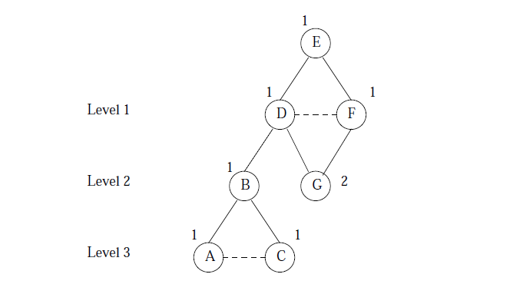 …(2)

Figure (2) above is the BFS representation of Figure (1) starting at node E. Solid edges are DAG edges and dashed edges connect nodes at the same level.

The second step of the Girvan-Newman algorithm is to label each vertex by the number of shortest paths from root to that node. We start by labeling the root as 1. Then, in a top down fashion, label each node Y by the sum of the labels of its parents.

In Figure (2) above,

* Label the root E with 1.
* At level 1, we have nodes D and F. Each has only E as a parent, so they too are labeled 1.
* At level 2, we have nodes B and G. D is the only parent of, so B has the label as that of D. G has parents D and F, so the label on G is 1 + 1 = 2.
* At level 3, A and C have B as the only parent, so their labels are the same as B, i.e. 1.

The third step is to calculate for each edge e, the fraction of shortest paths from the root node X to node Y that go through edge e and sum them over all Y. We start from the bottom for this computation for nodes and edges. Each node other than the root is implicitly given a credit of 1, representing the shortest path to that node. This credit is divided among nodes and edges above.

The rules for the calculation are as follows:

1. Each leaf in the DAG (a leaf is a node with no DAG edges to other nodes at levels below) is given a credit of 1.

2. Each non-leaf node gets a score equal to 1 plus the sum of the scores of the DAG edges from that particular node to the level just below.

3.A DAG edge e that enters a node Z from one level above is given a share of the score/credit of Z proportional to the fraction of shortest paths that go through e from the root to Z.

More formally, let Y1, Y2, . . . , Yk be the parents of Z. Let pi be the number of shortest paths from the root to Yi; calculated in figure(2). Then the score/credit for the edge (Yi , Z) is the credit of Z times pi divided by $\sum_{j =1 }^{k}{}$ pj.

After doing the credit calculation with each node as the root, we take the sum of the scores for every edge. Since each shortest path is traversed twice – once when each of its endpoints is the root – we divide the credit for each edge by 2.

We now perform the credit calculation for the BFS representation of Figure (2).

* At level 3, A and C are leaves, so they get credit 1. A and C have only one parent, so their credit is given to the edges (B,A) and (B,C), respectively.
* At level 2, the leaf G gets a credit of 1. B is a non-leaf, so it gets a credit =1 + (the scores of the DAG edges entering B from level below). As both the edges have score/credit as 1, the credit of B is 3. Intuitively 3 signifies that all shortest paths from E to A, B, and C go through B.

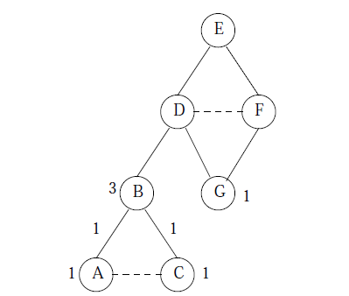

* At level 1, B has only one parent, D, so the edge (D,B) shares the entire credit of B, which is 3. D and F are the two parents of G. We bifurcate the credit G between the edges (F,G) and (D,G). From Figure (2), both D and F have been assigned 1, signifying that there is only one shortest path from E to nodes D and G. Thus, each of these edges gets half the credit of G; i.e., their credit is each 1*1/(1 + 1) = 0.5.

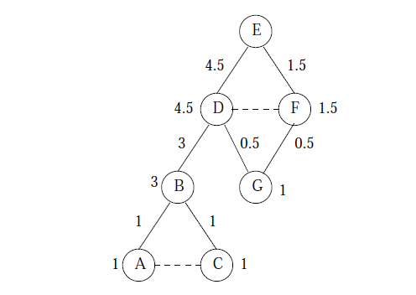... (4)

* We assign credits to the level 1 nodes. D is given 1 + (the credits of the edges entering D from level below), i.e., 3 and 0.5. So D has a credit of 4.5. For node F, the credit is is 1 + (the credit of the edge (F,G), i.e 1.5). Now, the edges (E,D) and (E, F) are given the credit of D and F, respectively, since they both have only one predecessor. The score on each of the edges in figure (4) is the contribution to the betweenness of that particular edge due to shortest paths from E. For example, this contribution (E,D) is 4.5.

In order to complete the betweenness calculation, we take each node as the root and find the betweenness scores for each edge and sum them. Finally, we divide by 2 to get the true betweenness, since every shortest path will be traversed twice, once for each of its endpoints.

The betweenness acts something like a measure of distance between the nodes. We now start with the edge removal process.

* We start with the graph and all its edges.
* Remove edges with the highest betweenness, until the graph has broken into a suitable number of connected clusters.

After making betweenness calculations using each node, and adding them up and dividing by 2, we get the below figure.

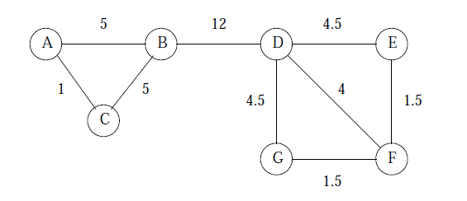

Clearly, edge (B,D) has the highest betweenness, so it is removed first. That leaves us with exactly the communities we observed make the most sense, namely: {A,B,C} and {D,E, F,G}. However, we can continue to remove edges by making the betweenness calculations again and removing the edges.

**5. Quality measures for clustering**

Graph clustering, a way of grouping similar vertices in a graph is an important technique, with a wide range of applications. In order to evaluate the quality of clusterings, we need certain quality measures to determine the effectiveness of our clustering algorithms and also provide insights on the dynamics of network as two how certain groups interact with one another. Several metrics have been proposed in literature but it's undecidable when it comes to the best measure for quality of clustering. Each metric on its own, stands independently and it's not concretely possible to compare them with each other. Here we review the four quality measures available in literature. The paper we refer to goes on to show that the quality metrics have biases in awarding reasonable scores to some kind of clusterings, especially in a network with large number of nodes.

Clusters are formed with regards to assortative mixing, that is, elements have a greater proclivity to connect with other elements with whom they share common qualities than with others . Using this on graphs, we can say that a cluster's elements will have stronger similarity between themselves, while also having less connections to other elements. Elemental similarity can be inferred from characteristics, such as edge density, vertex distance or labels. The metrics use only topological information, like vertex distance or edge density, to evaluate the quality of a cluster.

**5.1 Graph Notations**

A graph G = (V, E) consists of a set V of vertices and a set E = {(u, v)|u, v belong to V} of edges. We assume undirected graphs. |E(G)| = m is the number of edges of a graph G, and a number of edges connected to a vertex v is called as deg(v). We assume unweighted graphs, i.e. w(u,v) = 1 for all u,v in V. Else w(u,v) may have different non zero values. Also, consider E(Ci,Cj)j≠i is the set of edges connecting clusters Ci and Cj and E(Ci) is the set of edges in cluster Ci. Then, E(C) denotes the set of all internal edges for all clusters in C, and E(C') is the set of all inter-cluster edges in the graph. A clustering C represents the set of all clusters of a given graph, so that C = C1, C2 ,. . . ., Ck, and the number of clusters is k. The weight of all internal cluster edges of a single cluster is given by w(Ci). Using the same logic, w(C) denotes the weight sum of all inter-cluster edges. A graph cut K = (S, S’), where S’ = V \ S, divides a set of vertices V into two disjoint groups (S ∩ S’ = ɸ). The cost/weight of a cut is given by the weight sum of the inter-cluster edges. One other terminology is induced graph, that is formed by a subset of the vertices and edges of a graph so that G[Ci] = (Ci ,E(Ci)).

**5.1.1 Modularity**

Most popular validation metric for graph clustering is modularity. Modularity signifies that a good cluster must have a smaller than expected number of inter-cluster edges and larger than expected number of internal edges in comparison to a random graph with similar characteristics. The modularity score Q for a clustering is given by Equation 1, where e is a symmetric g ⤫ g matrix, g is the number of communities, whose element eij is the fraction of all edges in the graph that connect vertices in communities i and j, and Tr(e) is the trace of matrix e, i.e., the sum of elements from its main diagonal.

Q = Tr(e) - ||e2||

The modularity index Q represents values between 0 and 1, where 1 representing a grouping with very strong community characteristics. However, some cases may even give negative values. One example of such cases is in the presence of clusters with only one vertex. In such a case, the clusters have zero internal cluster edges and, therefore, offer a blank to the trace. A large numbers singleton clusters in a given clustering can cause the trace value to be so low as to overshadow other, possibly better formed, of its clusters and lead to very low modularity values.

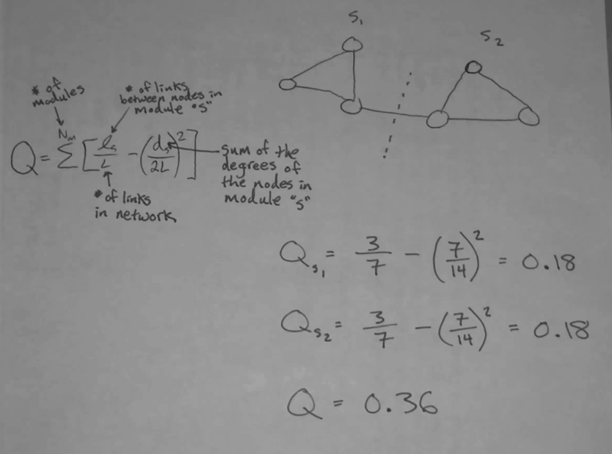

**5.1.2 Silhouette Index**

Silhouette Index uses concepts of cohesion and separation to evaluate clusters, using the node distance to measure their similarity. The silhouette index for a given vertex i is given by

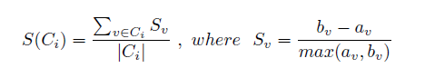

av is the average distance between vertex v and all the other vertices in the same cluster as it is, and bv is the average distance between v and all the vertices in the nearest cluster that is not v's. The silhouette index for a particular cluster represents the average value of silhouette for all its member vertices. The silhouette index has values between -1 and 1, with any negative value is not desirable, as it signifies that the average internal distance of the cluster is greater than the external one, which is a complete contradiction. The silhouette index has some limitations, though. I is a very costly metric to compute, requiring an all pairs shortest path execution. The other being how it behaves in the presence of singleton clusters. Since a singleton possesses no internal edges, its internal distance will be 0, causing its silhouette to wrongly score a perfect 1. Thus, clusterings with many singletons will always have high silhouette scores, with no regards to overall cluster qualities.

**5.1.3 Coverage**

The coverage of a clustering C (where C = C1, C2, . . . , Ck) is the fraction of the weight of all intra-cluster edges with respect to the total weight of all edges in the whole graph G.

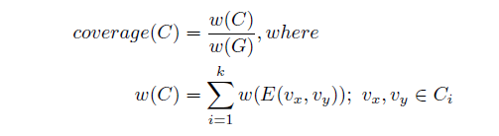

Coverage values range from 0 to 1. Higher coverage means that there are more edges inside the clusters than edges linking different clusters, which implies a better clustering. From its formulation, we can observe that the main clustering characteristic needed for a high value of coverage is inter-cluster sparsity. Internal cluster density is not considered by this metric, and so it causes a strong bias toward clusterings with less clusters. This can be seen in the example on Figure 1, where the clustering with two clusters would receive a better score than the clearly better clustering with three clusters.

**5.1.4 Performance**

Performance counts the edges that don't exist between the cluster's nodes and other nodes in the graph G, along with the number of internal edges in a cluster.

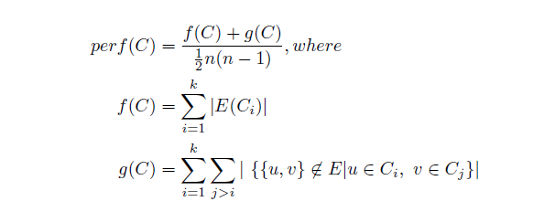

This assumes an unweighted graph, but there are also formulas for weighted graphs. Values range from 0 to 1, and higher values denote that a cluster is both internally dense and externally sparse and, therefore, a better cluster. However, if we consider that complex networks tend to be sparse in nature, when performance is computed for larger graphs, there is a possibility that g(C) becomes very high and it dominates all other factors in its formula, giving high scores indistinctively.

**6. CLUSTERING USING NETWORK TOPOLOGY**

Network structures are important for study as they help us understand relationships existing among the population of objects under observation. The main goal is to identify various communities existing in a network. This is a challenging open problem to which no method till now guarantees the exact matching of the calculated communities and empirically existing communities. This also greatly depends on underlying definitions which we are considering to judge a group of nodes as a cluster or community. Many algorithms existing in the literature do not consider a node as overlapping node that is , they assign every node to a particular community. However this algorithm consider a node as overlapping node if it satisfies the definition which is discussed below.

Here we discuss the definitions pertaining to the algorithm being discussed here.

***Community structure property***:- There is no universally accepted definition for a cluster to be classified as a community , however widely accepted notion of community is one which is densely connected from inside and sparsely connected from outside.

We discuss two types of communities namely strong sense communities and weak sense communities.

**Strong sense communities** have total internal connections greater than total external connections.

**Weak sense communities** have total internal connections less that total external connections but greater than maximum of all connections which it has with external communities.

***Community membership property***:- A node is defined as a member of a particular community given that it has the most number of connections within that community compared to any other community.

***Overlapping member property***:- We define two types of overlapping nodes here.

A node is overlapping node of **first type** if it has equal number of connections with more than one communities and even has equal distance from corresponding hub members.

A node is overlapping node of the **second type** if is tightly connected to communities and there should be very few connections between the corresponding communities after removing the node.

***Hub member***:- Hub member can be thought of as a centre of a community. It is defined as a node having maximum connections within a given community.

**6.1 Algorithms and Complexity**

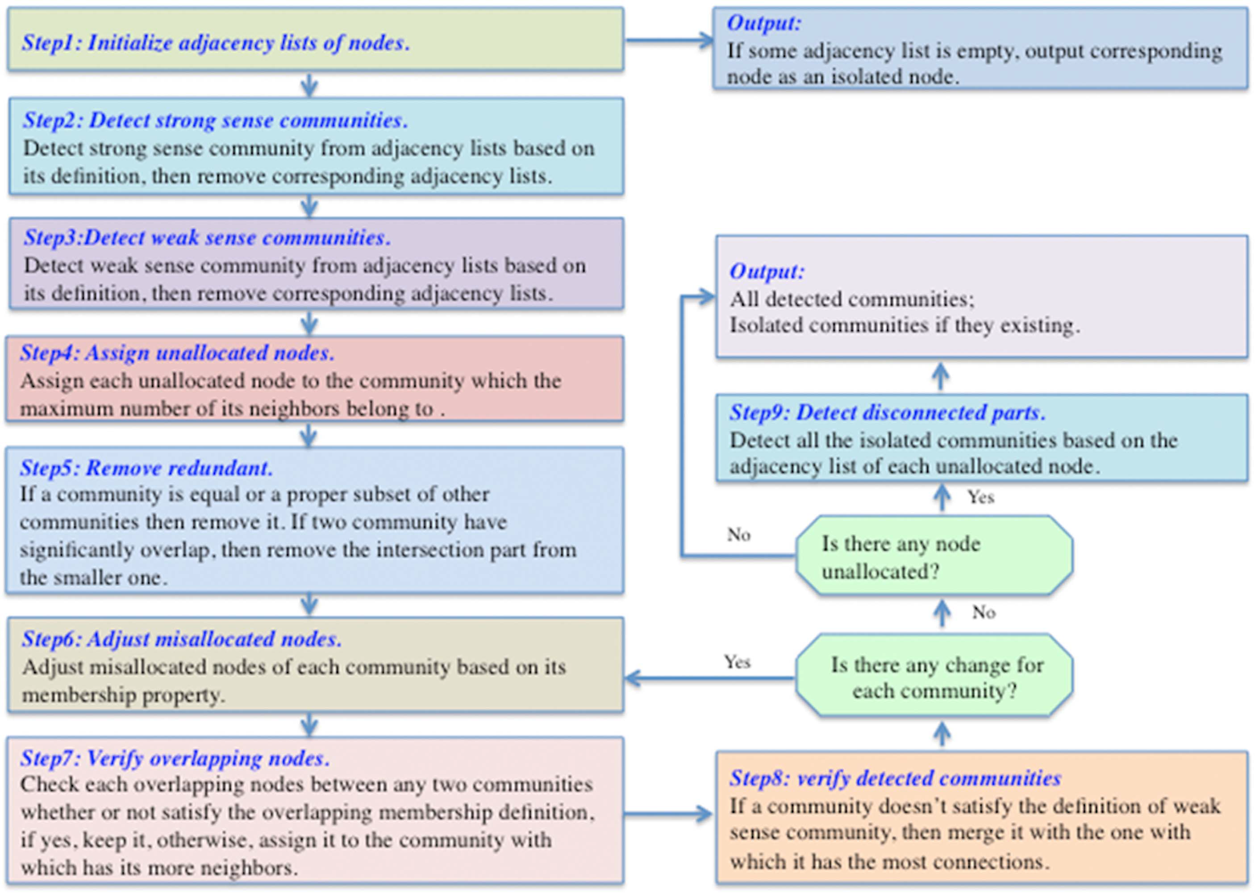

The above figure clearly gives an overview of how this algorithm work.

It is also important to study the complexity of an algorithm along with measuring accuracy of its results. Lower time complexity helps us in applying algorithm on a large scale network.

This algorithm consists of two stages: the first stage is

detecting communities, and the cost time complexity is O(k2+lkn), where n is the number of nodes,l is the maximum size of the initial adjacency lists and k is the number of detected communities.

The second stage is assigning membership among communities, and has a time complexity O(vk2+lk2+kn), where v is the maximum count of overlapping nodes. Thus, the total time complexity for both steps is O((v+l)k2+lkn). As a result, this algorithm can be efficiently applied to a network containing

thousands of nodes and edges and the typical execution time is around an hour on a typical CPU.

**6.2 Evaluation measures**

For evaluating the performance of the given algorithm, we discuss here two types of approach for measuring the accuracy of community partitions. However there is no universal accepted evaluation measure for community detection algorithms.

First one we used is modularity measure to check effectiveness of the given algorithm. It is based on the idea that random network structures do not exhibit community structure. It is defined as fraction of the edges that fall within the given groups minus the expected such fraction if edges were distributed at random.

Formally, given a particular division of a network into l communities

{c1,....,cl} ,the modularity of this division is

Q = $\frac{1}{2m}\{(\sum_{i,j}{}$ Aij - (ci , cj)}

where m is the number of edges , A is the adjacency matrix , ki is the degree of node i , ci is the type(community) and $δ$ is the Kronecker delta such that $δ$ (x,y) = 1 if x = y and 0 otherwise.

The second type of evaluation measure we used for evaluating community partitions is Normalized Mutual Information(NMI). It is defined as follows

$NMI(X|Y)=\frac{H(X)+H(Y)-H(X,Y)}{(H(X)+H(Y))/2}$

Where X corresponds to the real communities, Y corresponds to the predicted

communities, and H(X) denotes the entropy of random community X, whereas

H(X,Y) denotes the joint entropy of X and Y.

**6.3 Application of this algorithm on empirical networks**

***The Zachary karate club network*** is a famous empirical network. A conflict between club president John (node 34) and the instructor Mr. Hi (node 1) lead to division of 34 members of the university sports club into two groups. As Fig. (a) shows, the two communities calculated by the algorithm are exactly identical with the groups described by Newman. We note one thing here that some nodes should be defined as ‘‘overlapping nodes’’ based on the general definition discussed above. For example, node 10 and node 3 have equal numbers of connections with two communities, but they have different shortest path lengths with hub nodes 1 and 34. Consequently, we do not define them as overlapping nodes as per our definition.

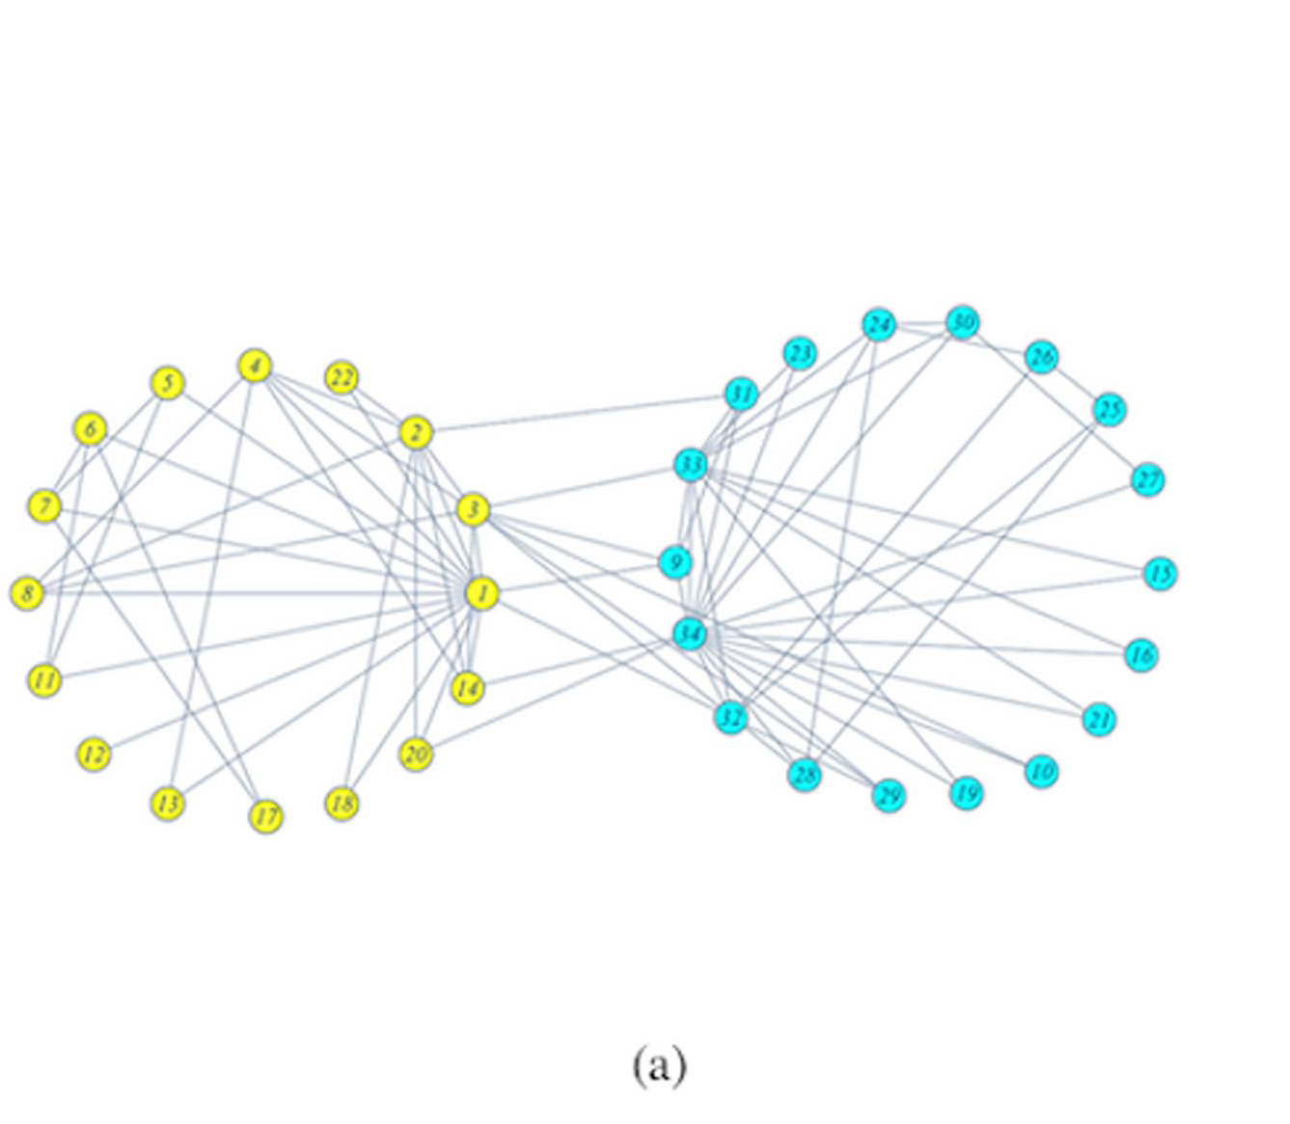

The ***American college football network*** is another widely used real life network discussed by Newman in 2004. There are 115 Division I-A teams that play 613 games during the regular fall season of 2000, and these teams are grouped into 11 different conferences, except for 8 independent teams. We found 11 strong sense communities using the given algorithm, as shown in Fig. (b). These communities are exactly identical to the 11 conferences of Division I-A teams, except for the 8 independent teams, which are assigned to ‘‘The Southeast Conference’’, ‘‘The Big East Conference’’ and ‘‘The Mid-American

Conference’’.

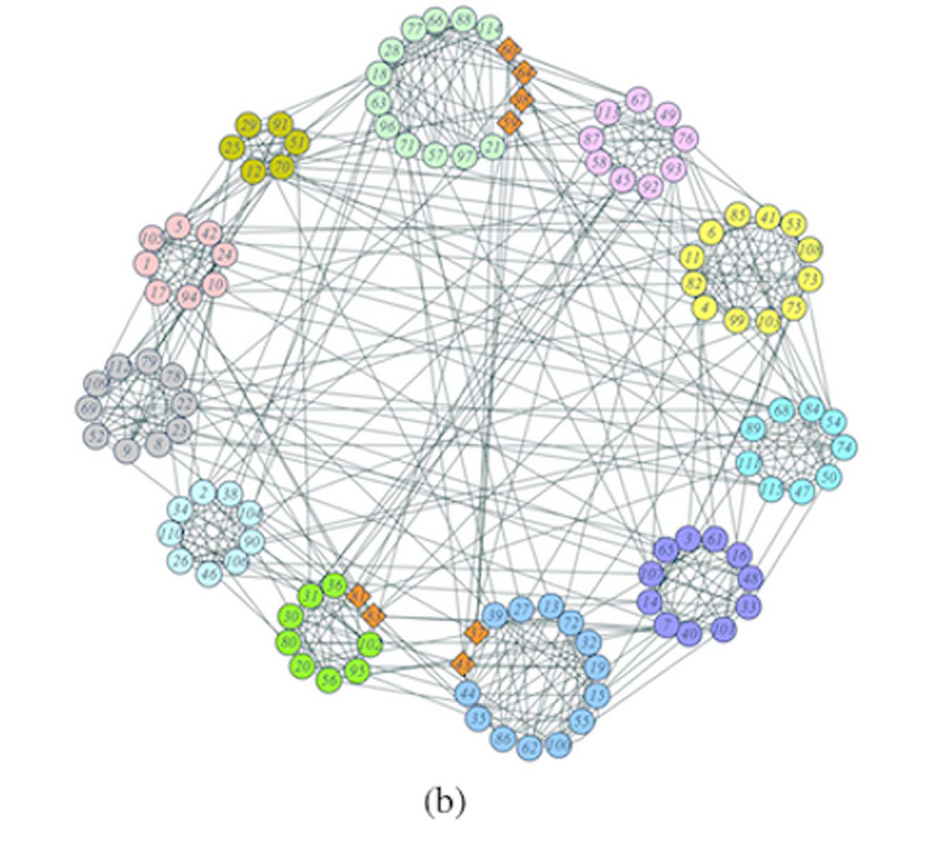Another real world network analysed using this algorithm is the ***Facebook network*** which is a directed friendships network compiled by Julian and Jure in 2012. There are in total 2888 users(nodes) and 2981 friendships(edges) in this network. An edge indicates that the user represented by the left node is a friend of the user represented by the right node. We identified 7 strong sense communities and 9 overlapping nodes, as shown in Fig. (c). The structure of this network clearly visible in the figure. All the friendships are established around ten users, so that we should have at most 10 communities.

Our partitions merge community pairs involving nodes 603 and 288, 710 and 714, and 2687 and 2699. We found that all these pairs are directly connected to each other and all the overlapping

nodes are of the first type.

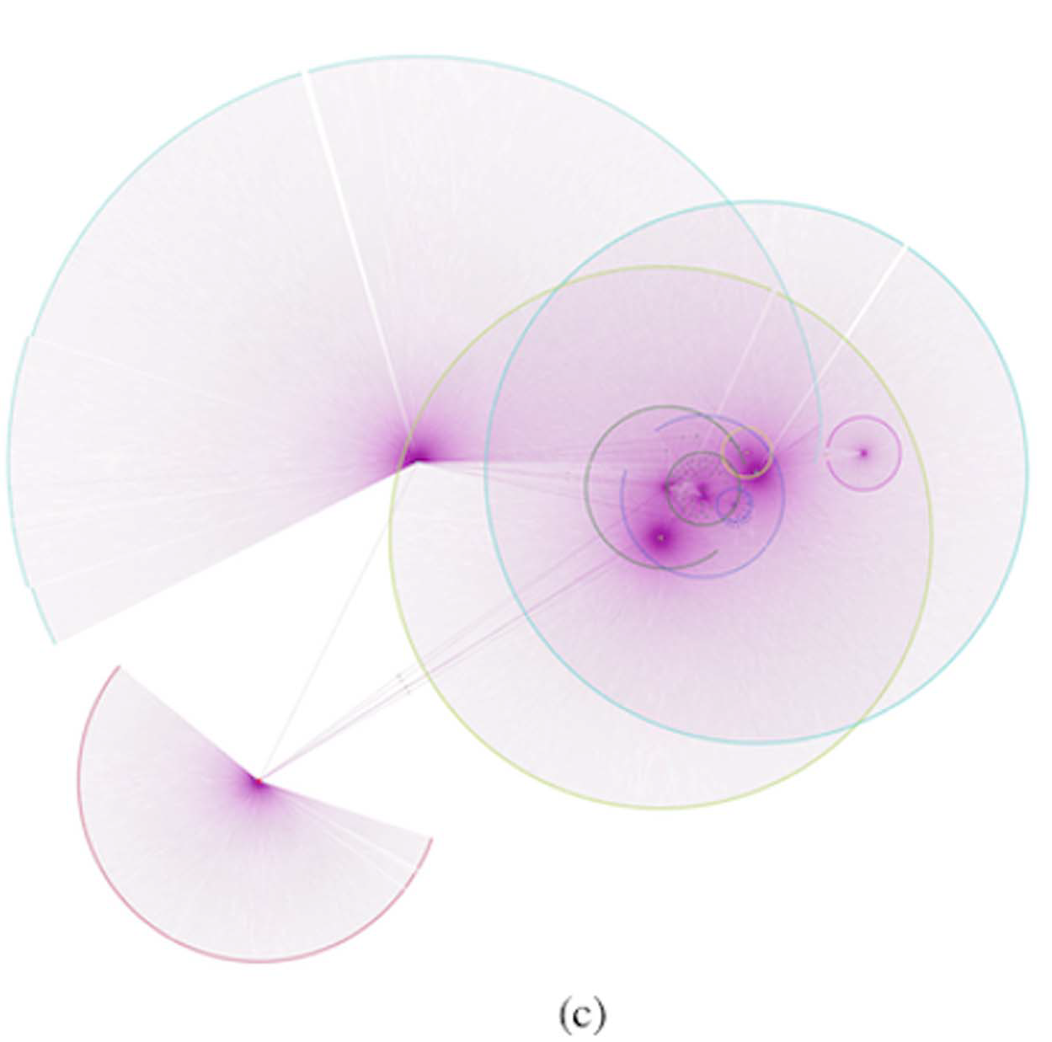

**7. Bibliography**

A.Y. Ng, M.I. Jordan, Y. Weiss

**On spectral clustering: Analysis and an algorithm**

T.G. Dietterich, S. Becker, Z. Ghahramani (Eds.), Advances in Neural Information Processing Systems, vol. 14, MIT Press, Cambridge, USA (2001)

**CS224W: Social and Information Network Analysis**

Jure Leskovec, Stanford University

http://cs224w.stanford.edu

Helio Almeida1, Dorgival Guedes1, Wagner Meira Jr.1, and Mohammed J. Zaki.

**Is there a best quality metric for graph clusters?**

Mahoney, Michael W. and Petros Drineas.

**CUR matrix decompositions for improved data analysis.**

*Proceedings of the National Academy of Sciences of the United States of America* 106 3 (2009): 697-702 .

Liu, Wei, Matteo Pellegrini, and Xiaofan Wang.

**Detecting communities based on network topology.**

*Scientific reports* 4 (2014): 5739.

M.E.J. Newman

**Finding community structure in networks using the eigenvectors of matrices**

Phys. Rev. E, 74 (3) (2006), p. 036104

M. Girvan and M. E. J. Newman

**Community structure in social and biological networks.**

Proceedings of the National Academy of Sciences of the United States of America, p.p. 7821--7826, vol. 99, June 2002.

Phys Rev E,2004.69(2):026113.Newman M E,Girvan M.

**Finding and evaluating community structure in networks.**

Phys Rev E,2004.69(2):026113.

N. Kishore Kumar and J. Schneider

**Literature survey on low rank approximation of matrices**

P. Drineas, A.Frieze, R.Kannan, S. Vempala, V. Vinay

**Clustering Large Graphs via the Singular Value Decomposition**

Machine Learning, 56, 9–33, 2004

S. Fortunato

**Community detection in graphs.**

arXiv:0906.0612, June 2009.

S. Schaeffer

**Graph clustering. Computer Science Review**

1(1):27–64, 2007

S. White and P. Smyth.

**A spectral clustering approach to finding communities in graphs**

Proceedings of the 5th SIAM International Conference

on Data Mining, Philadelphia, USA, 2005:76-84.

U Von Luxburg

[**A tutorial on spectral clustering**](https://scholar.google.com/scholar?oi=bibs&cluster=8671001140798821162&btnI=1&hl=en)

Statistics and computing, 2007

M.E.J. Newman

**Detecting community structure in networks**

Eur. Phys. J. B 38, 321–330 (2004)

**8. Appendix**

Code Snippets for Hierarchical Clustering

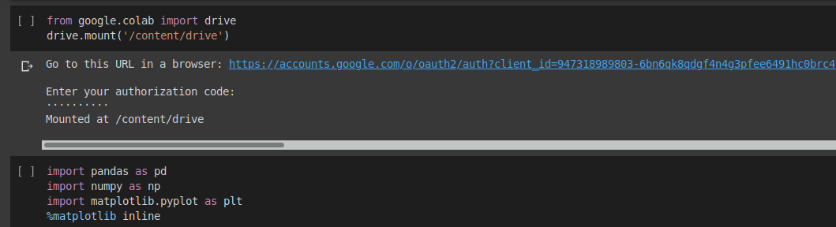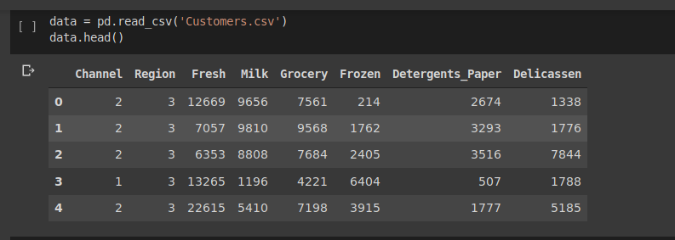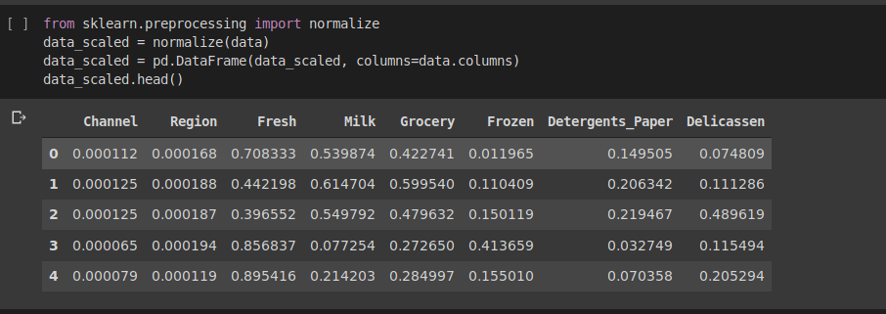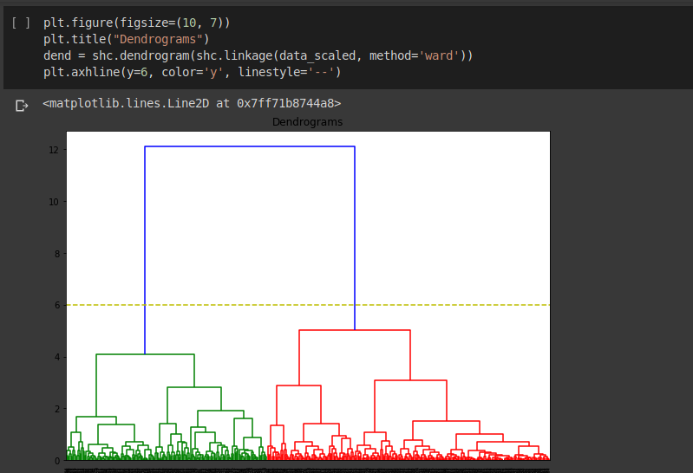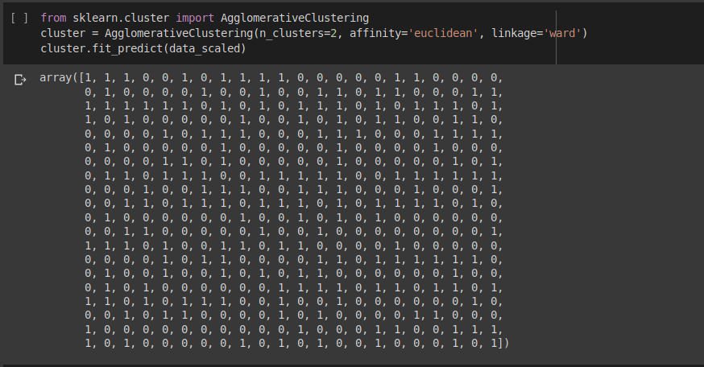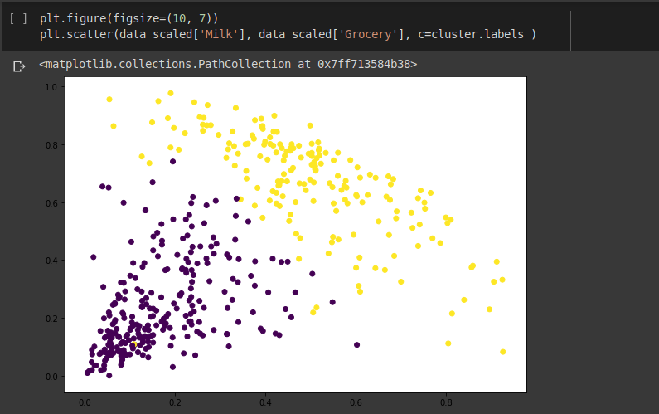

Code Snippets for Girvan-Newman Algorithm

